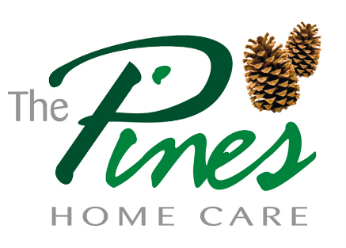
Complaining about your service
If you are feeling or

Talk to your support worker

You will not be in any trouble if you talk to us

If you are still unsure……
You can write a letter or Email
Cornerways House
School Lane
Ringwood
Hampshire
BH24 1LG
Or
Enquiries@thepinesgroup.co.uk
Ring us on 01425 471255

- We will address all complaints verbally within 24 hours.
- We will investigate your complaint within 7 days.
- We will write to you with the results of our investigation within 21 days.

How to complain

We endeavour to provide services that meet your needs.
However, there may be times when problems do occur.
In this situation please contact;
Mrs Debbie Gaskin or Claire Selby at -
01425 471255
Cornerways House, School Lane, Ringwood, Hampshire, BH24 1LG enquiries@thepinesgroup.co.uk
so that we can then discuss your problem and put things right
Or if you are still not happy you can contact your relevant social service or the Care quality commission.

Bournemouth Council care direct: 01202 454979

CARE QUALITY COMMISSION, NATIONAL CORRESPONDENCE CITYGATE, GALLOWGATE, NEWCASTLE UPON TYNE, NE1
TEL; 03000 616161
Dorset County Council Complaints Officer:
Email: dorsetdirect@dorsetcc.gov.uk
Tel: 01305 221061
Hampshire council: Phone 0300 555 1386
Out of hours 0300 555 1373
Updated 15/6/20

